ASSIGNMENT – 2

4.Create page using Gutenberg blocks.

- Log into WordPress to access the dashboard.
- Create a new page by adding a title and blocks.
- Add new blocks to customize the layout.
- Remove blocks if needed.
- Add headers and images using the Gutenberg editor.

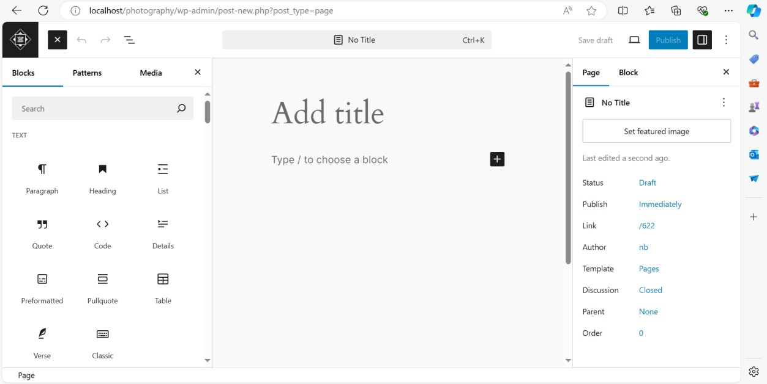

5.User role change and show your site.
There are five default user roles available in WordPress:

- Administrator
- Editor
- Author
- Contributor
- Subscriber

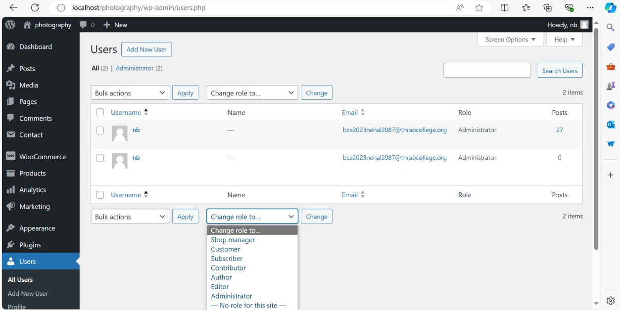

6. Install theme and e customize options using as per your site changing.
To install a theme on WordPress, you can follow these steps123:
- Log in to your WordPress account.
- Navigate to Appearance > Themes.
- On the Themes page, select "Add New" or search by theme type or price.
- Choose a theme.
- Click Download to begin the installation process.

Alternatively, you can install a theme using FTP or SFTP credentials
